- Purpose

The purpose of this document is to describe the specifications and design that will be implemented for the Application Functions in the ClearView system.

- General Requirements

Where appropriate, logic should be contained in try/catch blocks and any exceptions should be logged using the standard logging mechanisms.

- Specifications

Requirement #1: The system must only be accessible to a user that has a valid User Id and password combination.

Specification: In order to gain access to any component of the ClearView application, the user must sign in with a combination of credentials (User Id / Password).
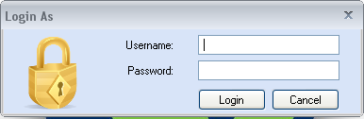
The passwords are required to be between 8 to 50 characters, and must contains at least one of each of the following character types:

- Lowercase letters
- Uppercase letters
- Numbers
- Special characters (#, @, !, etc.)

This combination at a minimum provides a possibility of more than 2 billion combinations.

Requirement #2: Functions within the system must be delegated by role. There will be three roles in the system:

- EPIC User- has access to scan functions only.
- EPIC Administrator- has access to scan functions as well as user administrative functions like the Users functions.
- System Administrator- has access to all areas of the ClearView software including Administrative functionality in the Capture, Camera and Report functions.

NOTE: Scan functions include the Manage Patients functions, Capture functions, Camera functions, and the Report functions excluding the Admin Page and all associated functions.

Specification: Two assignable roles and one unassignable role will be created within the ClearView system. The roles will be referred to as :
- CustomerAdmin
- CustomerUser
The relationship to the requirement is:
EPIC User = CustomerUser
EPIC Administrator = CustomerAdmin
The unassignable role is the system administrator and that will be only for the user 'Administrator'.

CustomerUser accounts will have access only to the Manage Patients functions, Capture functions, Camera functions, and the Report functions. Any functionality identified in the specifications for these areas as accessible by the Administrator only will not be available to the CustomerUser accounts.

CustomerAdmin accounts will have access to the Manage Patients functions, Capture functions, Camera functions, and the Report functions. Any functionality identified in the specifications for these areas as accessible by the Administrator only will not be available to the CustomerUser accounts. Additionally, the CustomerAdmin accounts will have access to the Manage User functions.

Requirement #3: The system must close after a specific amount of time of inactivity per HIPPA regulations. The initial amount of time should be 15 minutes. Inactivity is defined as no keyboard input or mouse clicks within the time frame.

Specification: A monitoring object will be created that will watch the windows message queue for messages related to either keyboard input or mouse clicks. If none of these messages are seen, a counter will be started to record how much time passes before one of these events is seen again. If the amount of time exceeds the defined amount of time that the application can be idle, the application will be automatically closed.
This check will be temporarily suspended when performing a calculation or analysis as there is no possibility of a keystroke or mouse click during these times.

Requirement #4: The system must contain a main menu in order for the user to easily navigate through the application.

Specification: A menu ribbon will be used containing the various core functionality that the ClearView system offers.
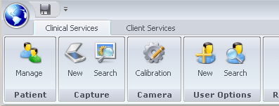
Based on the user’s role, some of the options may not be available to a given user. When an option is not accessible for a given user, the option will be removed and not displayed in the toolbar.

Requirement #5: The system must be windows based and be written using the .Net framework.

Specification: The application will be constructed using Visual Studio 2008 and will use C# as the base language. Mathematical analysis will be done using a combination of C# and Matlab.

Requirement #6: The system must persist data in a Microsoft SQL Server Database, version 2005 or greater.

Specification: The application will be developed on Microsoft SQL Server 2005 but will also be fully compatible with SQL Server 2008.

Requirement #7: The system must synchronize with an external controlling server. This server will be used to provide authentication for scans, archival functionality for images and other tasks.

Specification: The system will sync through a series of web service calls with a SaaS based application that is code named 'EPIC Central'. All transactions will take place across an encrypted https connection.

Requirement #8: The system should allow for the creation and management of users.

Specification: The system will allow the creation of an unlimited number of users. There is a dedicated section for user creation that can only be accessed by a CustomerAdmin or Administrator user. The section allows the basics of a user to be created.
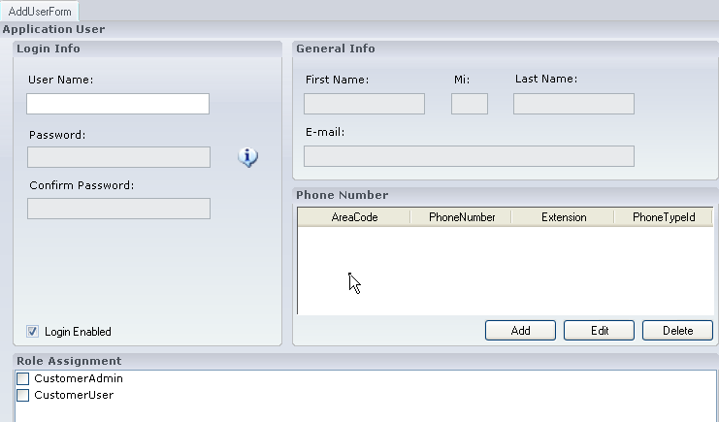
All values pertaining to a user are set here; the user will become active as soon as they are created. At any time, a user’s attributes can be edited by a CustomerAdmin or Administrator user. The edit page is the same as the user creation page from the aspect of functionality. All changes are applied immediately.

Requirement #9: The system should allow patients to be added and managed.

Specification: A button will be available on the main menu to allow the user to search the patient data and to enter new patient demographics. The specifications for the patient demographics are described in the Patient Services- Specifications.

Requirement #10: The system should allow a calibration process to the performed on the scanning devices.

Specification: A button will be available on the main menu to perform calibration. The process of calibration is described in the Camera Functions- Specifications.

Requirement #11: The system should allow for the capture of new images for a patient, as well as the analysis and results reporting for the images.

Specification: A button will be available on the main menu to perform the capture process. The capture process itself is described in the Capture Functions- Specifications.

Requirement #12: The system should allow historical scans (i.e., patient energized images) and the analysis results (i.e., report displays) to be searched and reviewed by a user.

Specification: A button will be available on the capture search dialog that will allow a user to view a historical scan. The view process itself is described in the Capture Functions- Specifications.

Requirement #13: The system should allow the currently logged in user to be changed without requiring a shutdown of the application.

Specification: An option is available on the main menu that allows a user to log in and effectively replace an existing user. The new user’s permissions, etc are then used to determine system behavior.

Requirement #14: The system should display the version number in the upper section of the main page.

Specification: The version number is shown in the title bar of the application and therefore can be seen from any section of the application.

Requirement #15: The system should allow for notifications to the user to be displayed in a noticeable area regardless of the function that is currently being performed.

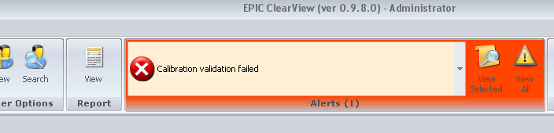
Specification: A notification area has been added to the application in the main menu area. The section will display that there is a message and the user can then drill into it to see the content.

Requirement #16: The system should allow the camera settings to be modified and persisted. This can only be done using the "administrator" login. These settings include: (firmware version, exposure delay, brightness and gain). Other settings are available, but will be implemented in the next iteration of the firmware.

Specification: A menu item has been added that appears only for the "administrator" login, all other users do not see the menu option.
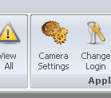

Clicking on this menu item will take the administrator to a page that will display the current settings for the system. The data will be persisted in a table in the database named "ScannerSettings".

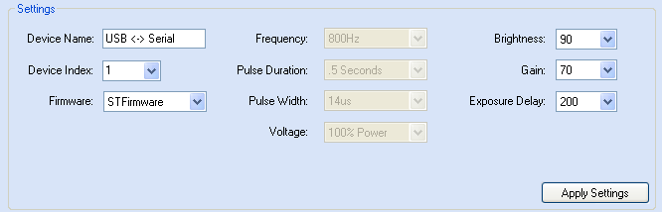

The version of firmware being used can be selected which will dictate the options are available. If the firmware is "STFirmware" then the options [Frequency, Pulse Duration, Pulse Width and Voltage] will not be available for selection.

This page also contains a simple testing apparatus that will allow the admin to capture an image to verify that the settings are acting as expected.

- Reference Documents

SS-001, Patient Services- Requirements
SS-002, Capture Functions- Requirements
SS-004, Camera Functions- Specifications

Document Revision History
Version Number: | Description of Change: | Date: | Updated by:
000 | Introduction | 5/24/11 | A. Mason
001 | Add specification to match new Requirement #16. | 5/24/11 | A. Mason

